Hadfield Infant School – SEND Information Report
2025-2026

Hadfield Infant School is a mainstream school which caters for children aged from 4 to 7 years old. The school is fully inclusive for all children and has provision to support a wide range of disabilities including wheelchair access, hearing loop system and a fully equipped disabled toilet with changing facilities. The school SENCO is Joanne Lowe.

Identification

How does the school know if my child needs extra help?
Your child may start school with a medical diagnosis or may have already been identified as needing additional support. You may already have other professionals involved with your child’s development. Alternatively, your child may need additional support and adjustments in order to support their learning progress.

Our key in school is early identification of any SEND so that appropriate support can be put in place. This will be done through:-

- Information from feeder nursery schools and parents. We gather as much information as possible before entry to school from discussions/records with pre school setting, health and from Parents/Carers at induction evening, class visits or specially arranged meetings.
- Baseline assessments in reception.
- Ongoing monitoring of progress through observations.
- Regular pupil progress meetings with school staff which will identify children who are struggling to making progress in termly assessments
- In conjunction with the class teacher the SENCO will use all information gathered including parental views to formulate a profile and a plan to set specific targets for progress.
- School will also be proactive in engaging and linking with outside agencies for guidance and support in specific areas of need i.e. physical, visual, behavioural. School will work in partnership with you and other agencies to secure the best possible support for your child.

Please note:
We recognise that every young child needs to be given time to settle into school life and aspects of social and emotional development and maturity may impact on lack of progress. We will therefore use our professional judgement in giving each child appropriate time, supportive resources and extra adult support before investigating any SEN.

What should I do if I think my child may have Special educational needs?
- If your child already has a diagnosis of SEND before starting school make an appointment with the Headteacher or SENDCO to discuss your child’s needs.
- Talk to school staff about your concerns. Be specific and give as much information/examples of any issues that you can including background or any other factors which you think may be having an impact on your child’s development or progress.
- School will support you in signposting to where you can get additional support which will help you to build up stronger network or provide additional information i.e. medical, parent partnership services,
- Be prepared to support your child at home. School will involve you in ways to support your child at home with specific tasks. This partnership will ensure that we are all working together and in the same way to ensure consistency of approach.
- School will work closely with you should there be the need to work towards a funding application or an EHCP i.e. paperwork that needs completing with specific information.
- School will review targets and evaluate progress at regular intervals and you will be invited to meetings with school staff every term either in school or virtually.
- There is a monthly SENDCO drop in session where you can pop in to chat with our school SENDCO. This is always shared on Classdojo.

How will school staff support my child?
Once a child has been identified as having SEND then this will be seen in two ways; either:-
a child will be identified as SEND Support or a child will have more complex needs and will have been identified as needing further assessments and an application for Inclusion Funding or an EHC plan may be submitted.


SEND Support
At this level a child will have been identified through a pathway of strategies as needing additional support with their learning. There may be several reasons for this for e.g. it may be due to social and emotional issues, communication needs or moderate learning difficulties. In summary there is a barrier to a child making appropriate progress and engaging with learning which requires your child to have additional support.
- A One Page profile will be set up which will map out specific details about your child; strengths, areas for support, attainment and strategies used so far. The profile will be used so that any member of staff working with your child will have full knowledge about how to work most effectively with your child.
- Additional support will be given to your child as directed by the class teacher. This may be within a small group or on a 1-1 basis.
- SEND is supported through differentiated work which will be planned by the class teacher with specific learning goals to work towards. This will ensure that your child is working within a level that is maximising their learning but that remains ambitious.
- Use of specific resources to support learning.
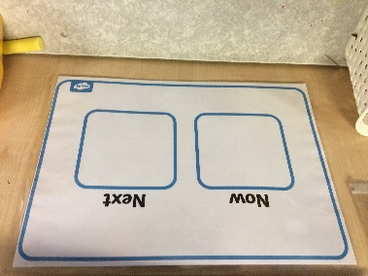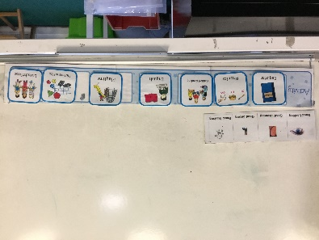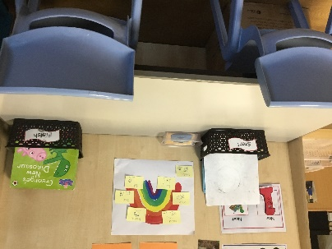

- Appropriate intervention programmes may be used to support your child’s learning. At the end of a specific block of time i.e. 6 weeks the plan will be reviewed and progress evaluated.
- Regular evaluations will take place. The class teacher on a regular daily basis will use the outcome of learning activities and tasks to plan and inform future learning for your child.
- The SENCO will support the class teacher with appropriate advice. A school Governor is also named as the Governor responsible for supporting SEN and will be kept updated with the progress of any child identified as having SEN.

Education, Health, Care plans (EHCP)
When a child may need additional, long term support a request may be made to the Local Authority for statutory assessment. Once a statutory assessment has been completed, which can be a very lengthy process due to advice, information and reports being needed from a wide range of professionals and parents, an EHC plan may be issued.
Any child who has an EHCP will have a specific plan to work within and which may involve a range of other professionals according to their level and category of need. This may be in the area of health where specific services are needed for e.g. visual impairment, physio etc or Social Care. Within such a plan a child may have additional funding to give extra adult support or resources.

Curriculum.
Hadfield Infant School follows two curriculums depending on the age of your child.
1. The Foundation stage follows the Early Years Foundation Stage curriculum which covers 17 areas of learning.
2. For children in Years 1 and 2 we follow the National Curriculum.

Within both of these areas adaptation will be the key and your child will be assessed regularly and appropriate learning and support given. Your child may also work better with a particular style of learning, for example, your child may work better using practical and “doing” skills whilst others may prefer a visual approach. Your child will again have been assessed and monitored by school staff so we have the knowledge about this and can apply the most appropriate strategies using the most effective resources and adult support to maximise learning.

Communication.
- Assessment is ongoing at Hadfield Infants and operates as a cycle. Teachers are continually assessing your child’s performance against set tasks and then this informs future planning. The cycle works as; ASSESS - PLAN – DO –REVIEW and is known as the “Graduated Approach.”
- You will be informed through regular meetings about your child’s progress. You may also be asked to support your child at home and if so you will be provided with information about how to do this. Staff will spend time with you to give appropriate parent training should this be required. You will have direct 1-1 contact with school via Classdojo to ask questions and share information.
- If your child has an EHCP there will be termly meetings with school staff and additionally an annual review where all professionals who are involved with your child will meet to review the progress against the specific plan. This will be used to inform new targets for progress for the following year and the reviewed plan will be sent to the Local Authority.

- As with all children in school you will have the opportunity to attend two Parents Consultation evenings through the year and you will also receive a written end of year report in July.

Well Being.
- If your child has a specific medical need then staff will be trained from appropriate health departments in how to address these needs if they occur in the school setting.
- The school will give medication should this be included in a specific medical plan.

We work hard to promote self-regulation and each class has a calm zone which children are encouraged to access and staff work hard to promote a positive school experience for all children.

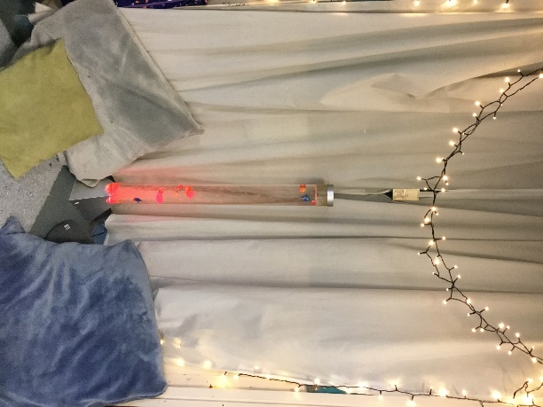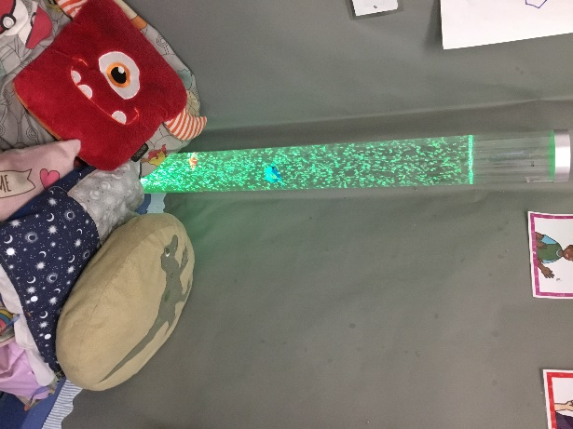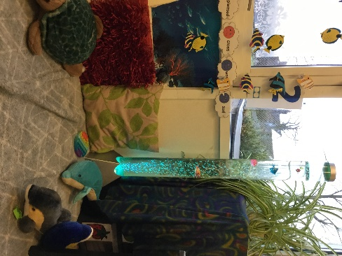

Specialist Help
- Hadfield Infant School has a designated SENCO –special educational needs co-ordinator. The Reception teacher Joanne Lowe has this role and has had expertise in the field of SEND for over 20 years. She has worked with many children with a wide range of SEND and is an Autism Advocate. A member of the Governing Body also has a role to support SEND within school. At our school we aim to ensure that we give your child the best possible chances to succeed.
- School will access outside agency support where it is felt by parents and staff to be the appropriate course of action and may include health professionals (i.e. physio, visual, hearing ), behavioural support or support for emotional/social issues.

Training
- Our SEND training is coordinated by Joanne Lowe as SENCO.
- We also have support staff in school trained in specific moving and handling which ensures that any child who has a disability is moved safely and appropriately.
- We have two members of staff who are trained in Makaton (sign language).
- All staff are trained in ‘Making Sense of Autism and ‘Good Autism Practice’’.
- Staff are also trained to meet any specific needs of a pupil they may be supporting for example in the case of medical care plans (gastrostomy feeding, diabetic support, anaphylactic injections etc). Training will always be done by trained medical practitioners.
- Our whole school staff has had training in dyslexic awareness, ADHD awareness, Sensory Processing Difficulties and ASC.

Inclusion

Our school strives to ensure that any child with SEND will be fully included into the full life of the school including out of school activities. We make reasonable adjustments wherever possible to ensure that a full school curriculum can be accessed. We have a regular outdoor activity known as Forest Schools when children from Y1 and Y2 go for outdoor learning experiences. We endeavour to include every child. We always consult with parents when trips outside school are planned and often ask for their support on trips.

Access.

Hadfield Infants is fully wheelchair accessible both inside and out. We also have a disabled toilet fully equipped with a changing mattress and hoist. There is a hearing loop system in the hall and the same facility, should it be needed, will be present in the classroom where a hearing impaired child will be taught.
Whatever the child’s needs are we will endeavour, through working with appropriate outside agencies, to support them with specialist equipment to meet their needs.

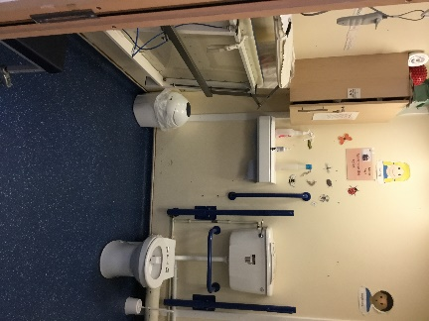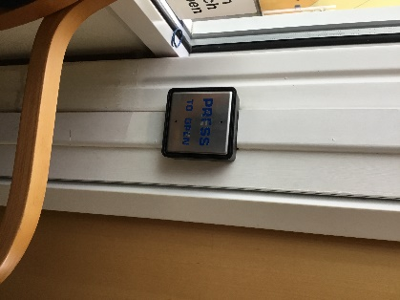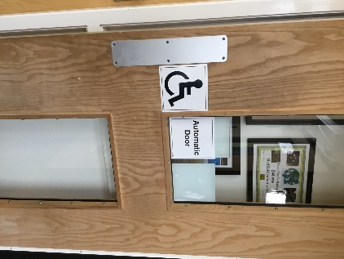

Transfer
- When a child starts our school who already has a diagnosis or SEND already identified, plans are put in place to work with parents and their child before entry to school. A member of staff will always visit/discuss with the pre-school provider to gather as much information as possible in order to make transition run smoothly. We also ask to meet with parents. If there is a multi -agency meeting before entry to school we will attend again to ensure we have relevant information for transition.
- The majority of our children transfer to St Andrews Junior School when they are 7 and again we meet with staff passing all information we have to aid a smooth transition. Extra visits and resources are often planned with the junior school for children with SEND if required. All records will be transferred including specific plans that have been followed.

Decision making.
- Under the new SEND Code of Practice introduced into schools in September 2014 there is a key principle that parents of children with SEND should participate in decision making. In order to make this effective school will provide parents with accurate information in order to enable them to participate effectively in this decision making
- Support for your child is discussed with teachers and SENCO with close interactions and engagement with parents. We aim to have a collaborative and creative problem solving approach between schools and parents.
- All support is reviewed after a set agreed period and then decisions are made on what the next steps need to be.
- For a child who has been issued an Education Health Care Plan parents will be involved in making decisions involving personal budgets and payments.

Involvement
We value the effective engagement of parents and the beneficial impact on children’s progress. In our school therefore:-
- Parents are very welcome to come into school; we have reading friends, support in class and an active Parent Teacher Association.
- We encourage parents/carers to support your child’s learning at home using learning activities which school can suggest or provide.
- We invite parents to come on school trips where the support will benefit your child.
- We invite parents to information giving sessions which may include how to support your child at home with reading, numeracy or e safety.

Local Offer.
• The headteacher, can be contacted on the school number (01457 853950) or via e mail on the school address - info@hadfield-inf.derbyshire.sch.uk. The school SENDCO can be contacted on j.lowe@hadfield-inf.derbyshire.sch.uk
• Derbyshire Education Authority has a website outlining the Local Offer and can be found at:- http://localoffer.derbyshire.gov.uk/

Other Useful Contacts

Derbyshire SEND Service localoffer.derbyshire.gov.uk 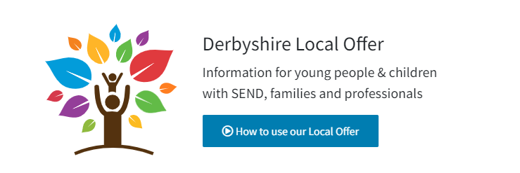

DIASS derbyshireiass.co.uk


.

