- All new vocabulary will be displayed on Working Walls in the classroom environment.  - WAGOLL to use for whole class teaching demonstrating the skills and vocabulary expectations. |  |  |  |  |  |  |  |  |  |  | - Learning is progressive and therefore texts and skills need to be taught in chronological order.  - New ambitious vocabulary will be introduced and pre taught by staff weekly using a range of adjectives, verbs, nouns, adverbs.
Autumn 1
Planet Protectors
Text and Genre | Retell- Somebody Crunched Colin  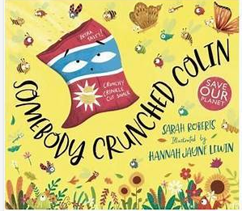 |  | Retell- Greata and the Giants  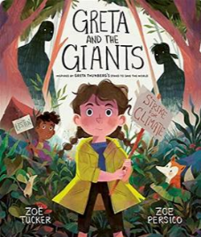 |  |  |  |  | 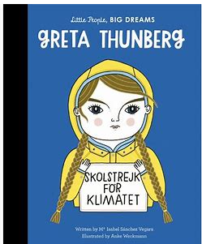  Recount of Greta Thunberg’s Life |  |  |  |  |  | Retell- The Forgotten Forest  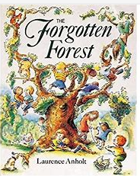 |  |  |  |  | Retell- One Plastic Bag  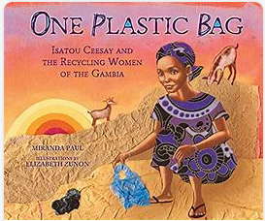 |  |  | 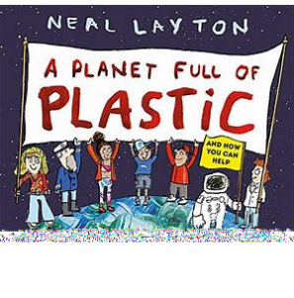  Non- Chronological Report on Plastic Pollution
Year 2 Genre Progression | May create a story map or use pictures as prompts  Description of the character and setting  No comma would be used after the fronted adverbial opener until Year 3. |  | May create a story map or use pictures as prompts  Description of the character and setting  No comma would be used after the fronted adverbial opener until Year 3. |  |  |  |  | Chronological events  Use proper nouns  Details to interest the reader  Exclamative sentence to close |  |  |  |  |  | May create a story map or use pictures as prompts  Description of the character and setting  No comma would be used after the fronted adverbial opener until Year 3. |  |  |  |  | May create a story map or use pictures as prompts  Description of the character and setting  No comma would be used after the fronted adverbial opener until Year 3. |  |  | Title  Introduction  Include question  Subheadings (given)  Paragraphs (from given structure)  Ending/closing sentence  Scientific/technical language
Handwriting –Lower case letters are the same height.

Year 2  Grammar and Punctuation | Use a wider range of time words (time adverbial / time adverb) at the start of my sentences. |  | Use a wider range of openers at the start of my sentences. |  |  |  |  | Use a wider range of exciting openers and use an exclamation mark at the end of an exciting sentence. |  |  |  |  |  | Use a wider range of question openers and end with a question mark. |  |  |  |  | Use the conjunctions ‘because’, ‘that’ and ‘and’ in fiction writing. |  |  | Use the conjunctions ‘because’, ‘that’ and ‘and’ in non-fiction writing.
Year 2 Spelling | *“Dictation gives children opportunities to practise and apply their spelling knowledge and segmenting skills, without having to compose sentences by themselves. It requires them to distinguish between the sounds they hear in order to choose the correct graphemes to represent the sounds and to form the letters correctly.” Research and Review, May 2023
Autumn 2
Time Travel
Science – |  |  |  |  | History |  |  |  |  |  |  |  |  |  |  | Geography:
Year 2  Genre Progression | Retell- Hovis the Hedgehog  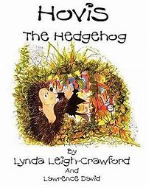 |  | Setting Description of the Barn  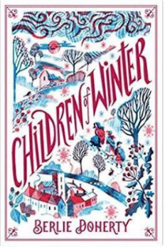  Children of Winter |  |  |  |  | Informal Letter to mum and dad. |  |  |  |  |  | 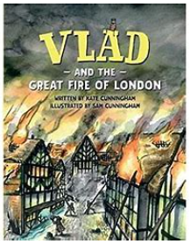  Diary Entry- Vlad and the Great Fire of London |  |  |  |  | Retell- A section of the story  (Use the animation as stimulus as well as the book.)  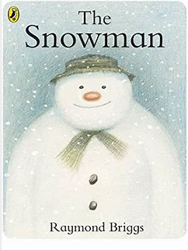 |  |  | Instructions to Build A Snowman
Handwriting - Leave equal spaces between words.
Year 2  Genre Progression | May create a story map or use pictures as prompts  Description of the character and setting  No comma would be used after the fronted adverbial opener until Year 3. |  | Describe using the senses – what the character can see, hear, smell, touch and how they feel  Identify where – using prepositions  Similes  Expanded Noun Phrase  Range of openers (Far away, In the distance)  Past tense  If the setting writing is part of a story, rhetorical questions relating to the characters may be asked. |  |  |  |  | Address and date (Given)  Greeting (From a choice)  Past tense  Introduction (why you are writing)  More details  Final sentence written in the present tense (what the sender wants the recipient to do next)  Signing off (given)  Personal thoughts and feelings  Informal (use contractions) |  |  |  |  |  | Dear Diary and date  Add in private / secret thoughts and feelings  First person (I, We, My)  Openers –  Past tense  Use time adverbials to show when things happened  Chronological order  Simple conclusion looks ahead to the future (future tense using the conjunction ‘If’) and includes a rhetorical question  Informal language (contractions) |  |  |  |  | May create a story map or use pictures as prompts  Description of the character and setting  No comma would be used after the fronted adverbial opener until Year 3. |  |  | Title with question  What you need  Introduction with a question  Command sentence / Imperative verbs as openers  -ly adverb at the start of the sentence  Top tip / warning  Link to fictional writing
Year 2 Grammar and Punctuation | Use an expanded noun phrase (noun phrase) using one or more adjectives. |  | Use commas in a list |  |  |  |  | I can use an apostrophe to show contraction in my written work. |  |  |  |  |  | Consolidation of using contractions.  Use the present and past tense correctly.  Use when and if as openers/at the start of a sentence. |  |  |  |  | Consolidation of previously taught skills, |  |  | Recognise and write a command sentence with a imperative (bossy) verb and punctuate it with an exclamation mark or a full stop.
Year 2  Spelling | *“Dictation gives children opportunities to practise and apply their spelling knowledge and segmenting skills, without having to compose sentences by themselves. It requires them to distinguish between the sounds they hear in order to choose the correct graphemes to represent the sounds and to form the letters correctly.” Research and Review, May 2023
Spring 1
Super Humans and Amazing Athletes
Year 2  Genre Progression | 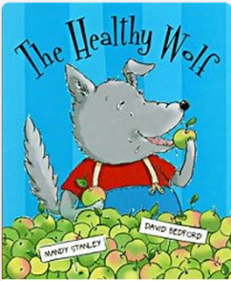  Retell- The Healthy Wolf |  | 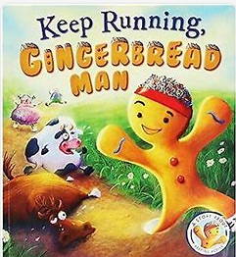  Retell- Keep Running Gingerbread Man |  |  |  |  | Instructions- Hygiene (Hand Washing)  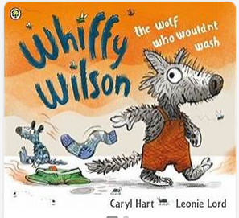  Whiffy Wilson Book as hook |  |  |  |  |  | Recount- Marcus Rashford  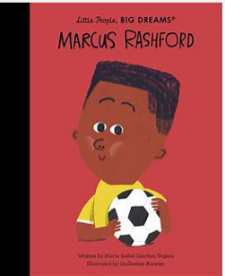 |  |  |  |  | Formal Letter- Writing to Marcus |  |  | Non-Chronological Report- Keeping Healthy  
Handwriting- Start using some of the horizontal strokes to join letters.

Year 2 Genre Progression | May create a story map or use pictures as prompts  Description of the character and setting  No comma would be used after the fronted adverbial opener until Year 3. |  | May create a story map or use pictures as prompts  Description of the character and setting  No comma would be used after the fronted adverbial opener until Year 3. |  |  |  |  | Title with question  What you need  Introduction with a question  Command sentence / Imperative verbs as openers  -ly adverb at the start of the sentence  Top tip / warning  Link to fictional writing |  |  |  |  |  | Chronological events  Use proper nouns  Details to interest the reader  Exclamative sentence to close |  |  |  |  | Address and date (Given)  Greeting (From a choice)  Past tense  Introduction (why you are writing)  Final sentence  Signing off (given)  Thank you, letter, following a school trip / visitor |  |  | Title  Introduction  Include question  Subheadings (given)  Paragraphs (from given structure)  Ending/closing sentence  Scientific/technical language
Year 2  Grammar and Punctuation | Recognise and write an exclamative sentence using What or How. |  | Use the conjunction ‘but’. |  |  |  |  | Use a question in non-fiction writing.  Use when and if as openers/at the start of a sentence. |  |  |  |  |  | Use the conjunctions ‘because’, ‘that’ and ‘and’ in non-fiction writing. |  |  |  |  | Consolidation of skills. |  |  | Use the conjunction ‘or’.
Year 2 Spelling | *“Dictation gives children opportunities to practise and apply their spelling knowledge and segmenting skills, without having to compose sentences by themselves. It requires them to distinguish between the sounds they hear in order to choose the correct graphemes to represent the sounds and to form the letters correctly.” Research and Review, May 2023
Spring 2
Explorers and survival
Science – Living Things and their habitats (cold places) |  |  |  |  |  |  |  |  |  |  |  | History- Polar Explorers
Handwriting- Start using some of the horizontal strokes to join letters.
Text and Genre | 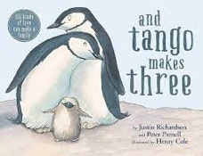  And Tango makes three – Retell |  |  | 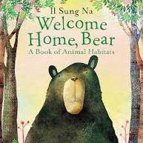  Welcome Home Bear – Retell |  |  |  |  | 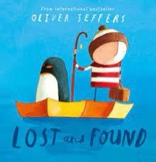  Lost and Found – Retell |  |  |  |  |  |   Retell – The Great Explorer |  |  |  |  | Recount – Amelia Earhart  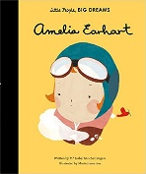
Genre Progression | May create a story map or use pictures as prompts  Description of the character and setting  No comma would be used after the fronted adverbial opener until Year 3. |  |  | May create a story map or use pictures as prompts  Description of the character and setting  No comma would be used after the fronted adverbial opener until Year 3. |  |  |  |  | May create a story map or use pictures as prompts  Description of the character and setting  No comma would be used after the fronted adverbial opener until Year 3. |  |  |  |  |  | May create a story map or use pictures as prompts  Description of the character and setting  No comma would be used after the fronted adverbial opener until Year 3. |  |  |  |  | Chronological events  5w’s to introduce  Use proper nouns  Emotions to describe feelings (I was excited when….)  Final statement (My favourite part was…)  Details to interest the reader  Exclamative sentence to close
Year 2  Grammar and Punctuation | Add the suffix -ly to change a word from an adjective to an adverb and use as a sentence opener. |  |  | Consolidation of the conjunction ‘but’.  Use an expanded noun phrase (noun phrase) using one or more adjectives. |  |  |  |  | Use the conjunctions ‘because’, ‘that’ and ‘and’ in fiction writing. |  |  |  |  |  | Use a comma to separate adjectives when describing a noun. |  |  |  |  | Consolidation of using an exclamative sentence using What or How.  Consolidation of using because, but and and in non-fiction writing.
Year 2  Spelling | *“Dictation gives children opportunities to practise and apply their spelling knowledge and segmenting skills, without having to compose sentences by themselves. It requires them to distinguish between the sounds they hear in order to choose the correct graphemes to represent the sounds and to form the letters correctly.” Research and Review, May 2023
Summer 1
Mad about Mini Beats
History: National / global history |  |  |  |  |  | Science- Living things and their Habitats (micro habitats) |  |  |  |  |  |  |  |  |  |  | Geography: compass directions / maps.
Text and Genre | 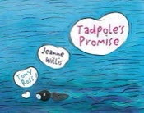  Retell – Tadpole’s Promise | 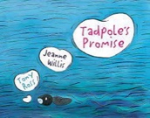  Diary Entry – Tadpoles Promise |  |  |  |  | SATS |  |  |  |  |  | Superworm – Character Description  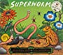 |  |  |  |  | 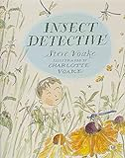  Instructions – for a butterfly enclosure |  |  | 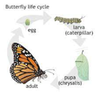  Explanation of the Life Cycle of a butterfly.
Year 2  Genre  Progression | May create a story map or use pictures as prompts  Description of the character and setting  No comma would be used after the fronted adverbial opener until Year 3. | Dear Diary and date  Add in private / secret thoughts and feelings  First person (I, We, My)  Openers –  Past tense  Use time adverbials to show when things happened  Chronological order  Simple conclusion looks ahead to the future (future tense using the conjunction ‘If’) and includes a rhetorical question  Informal language (contractions) |  |  |  |  |  |  |  |  |  |  | Present tense  Separate character description  Describe how the character looks using adjectives and simple similes  Use because / when to describe their personality and actions  Use an ! in an exciting sentence  Include how other characters feel about the character I am describing  Say what I like / dislike about the character. Identify where – using prepositions Select effective vocabulary and up level. Begin to experiment with word order in sentence structure, -ly adverbs to describe how an action was performed. |  |  |  |  | Title with question  What you need  Introduction with a question  Command sentence / Imperative verbs as openers  -ly adverb at the start of the sentence  Top tip / warning  Link to fictional writing  Setting up the butterfly habitat / how to be a good mini-beast detective / make your garden more attractive to insects. |  |  | Title  Brief introduction  Scientific language  Subheadings provided by the teacher  Paragraphs  Facts and appropriate order
Handwriting- Start to join handwriting.
Year 2 Grammar and Punctuation | Use an apostrophe to show singular possession. | Consolidation of using when and If. |  |  |  |  |  |  |  |  |  |  | To use effective word choices and create a list of adjectives to describe a noun. |  |  |  |  | Consolidation of using a command sentence with an imperative (bossy) verb and punctuate it with an exclamation mark or a full stop.  Consolidation of using commas in a list. |  |  | Consolidate all skills in non-fiction writing.  Use a question in non-fiction writing.
Year 2  Spelling | *“Dictation gives children opportunities to practise and apply their spelling knowledge and segmenting skills, without having to compose sentences by themselves. It requires them to distinguish between the sounds they hear in order to choose the correct graphemes to represent the sounds and to form the letters correctly.” Research and Review, May 2023
Summer 2
Ocean Adventures
Science - Living things and their Habitats (Water and Hot Places) |  |  |  |  |  |  |  |  |  | History – The Titanic
Text and Genre | Somebody Swallowed Stanley – Diary  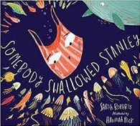 | 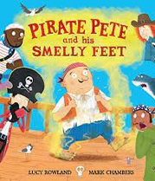  Pirate Pete and his Smelly Feet – Retell |  |  |  |  | Recount Leavers Trip  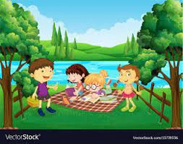 |  |  |  |  |  | Non-chronological Report – The Titanic  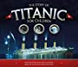 |  |  |  |  |  |  |  | 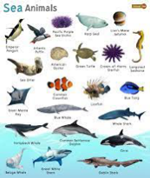  Ocean Riddles
Year 2  Genre Progression | Dear Diary and date  Add in private / secret thoughts and feelings  First person (I, We, My)  Openers –  Past tense  Use time adverbials to show when things happened  Chronological order  Simple conclusion looks ahead to the future (future tense using the conjunction ‘If’) and includes a rhetorical question  Informal language (contractions) | May create a story map or use pictures as prompts  Description of the character and setting  No comma would be used after the fronted adverbial opener until Year 3. |  |  |  |  | Chronological events  5w’s to introduce  Use proper nouns  Emotions to describe feelings (I was excited when….)  Final statement (My favourite part was…)  Details to interest the reader  Exclamative sentence to close |  |  |  |  |  | Title  Introduction  Include question  Subheadings (given)  Paragraphs (from given structure)  Ending/closing sentence  Scientific/technical language |  |  |  |  |  |  |  | What am  I?  Openers  New clue, new line  Present tense  , but  Conjunctions – and, that, When, If, or, because  Tease the reader  Commas in a list  Adjectives
Handwriting- Start to join handwriting.
Year 2  Grammar and Punctuation | Use the conjunctions ‘that’ and ‘or’ | Write in the progressive past tense.  Suffixes (-ment, -less, -ful, -ness) |  |  |  |  | To use effective word choices and create a list of adjectives to describe a noun.  Progressive Tenses |  |  |  |  |  | Consolidation of using a comma to separate adjectives when describing a noun. |  |  |  |  |  |  |  | Consolidate all skills.  (Revisit the ‘or’ conjunction.)
Year 2  Spelling | *“Dictation gives children opportunities to practise and apply their spelling knowledge and segmenting skills, without having to compose sentences by themselves. It requires them to distinguish between the sounds they hear in order to choose the correct graphemes to represent the sounds and to form the letters correctly.” Research and Review, May 2023

